Availablity sets:

When you are deploying virtual machine with application installed, you never know about the infrastructure where those VM deploying either VM launching in same physical server or different physical server.

-Physical server has- same network, same storage and same power cable if anything wrong with one of this then the VM no-longer will be available.

-Availability set will come up with the solution with this problem. You all resources will deploy in different physical server which will increase SLA 99.95% availability.

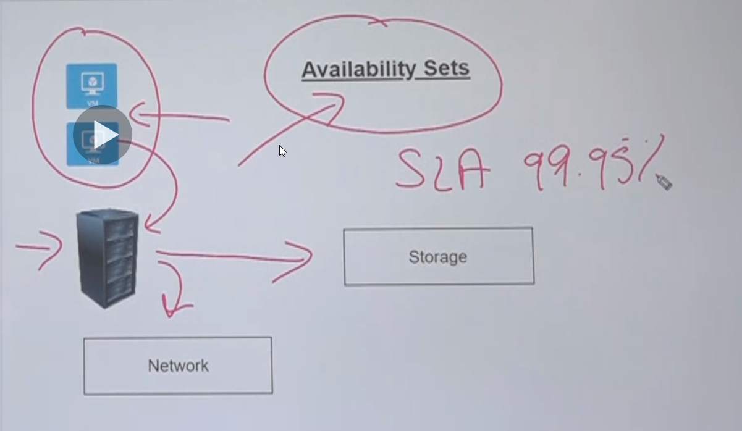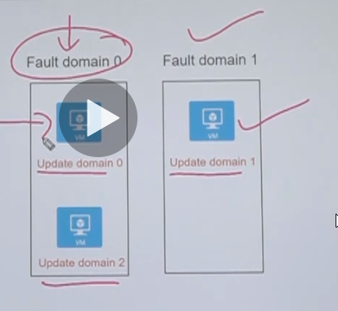

There is two parts of availability set 1. Fault domain (will be max 3) and 2. Update domain (will be max 20)

**Fault domains-** are used to define the group of virtual machines that share a common source and network switch. You can have up to 3 fault domains.

**Update domains-** are used to group virtual machines and physical hardware that can be rebooted at the same time. You can have up to 20 update domains. When patches are update in different update domain (eg.update 0) which will not affect other server located in other update domain(update domain 1).

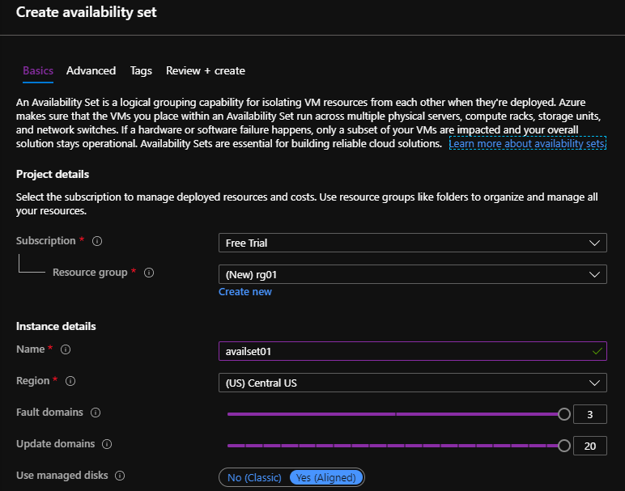

--When you are creating VM that is the time to create availability set later will not be possible to add. you can create same VM page or create separately searching the availability and attached with VM creating page.

-if you create separate availability set then you must choose same region same as VM.

---use managed disks should be yes (Microsoft recommended)

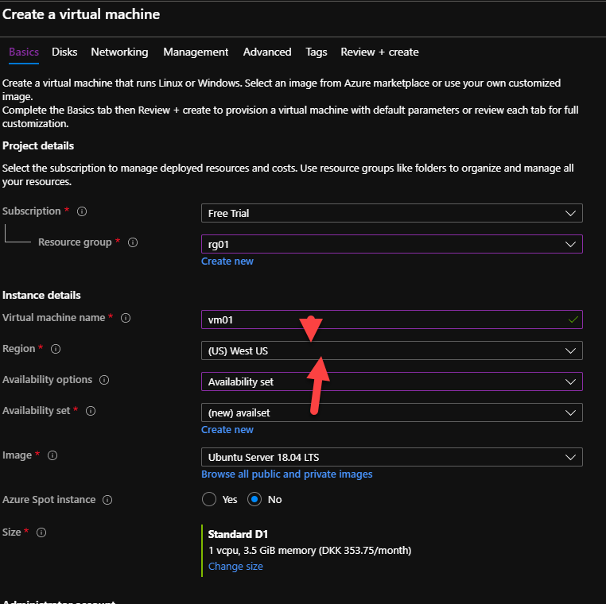

After deploying first VM01:

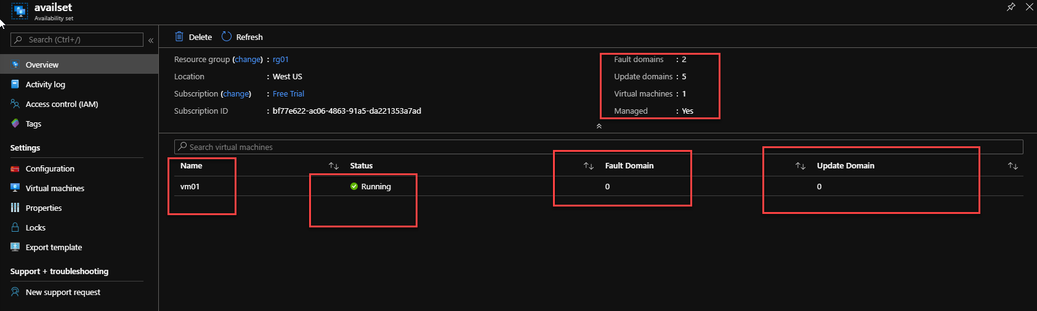

After deploying second VM02 with same availablity.

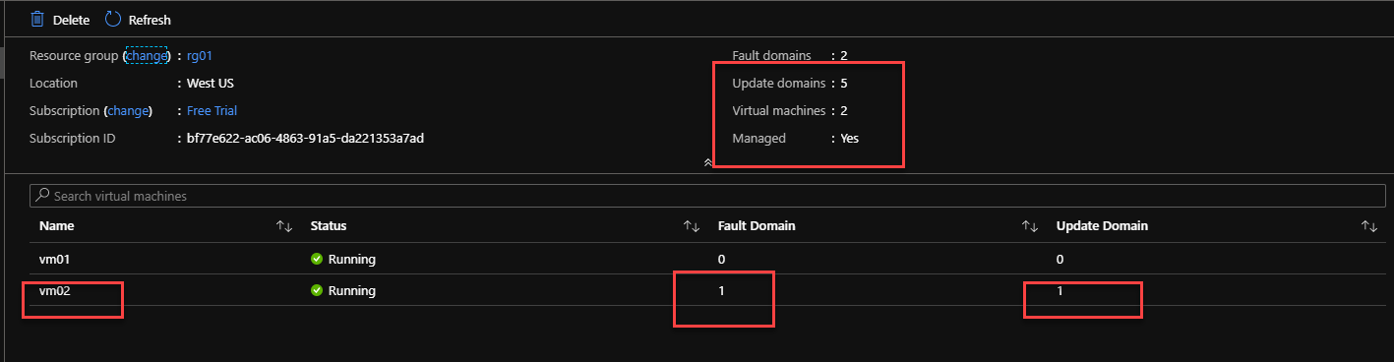

If faultdomain 0 down still fault 1 will be available.

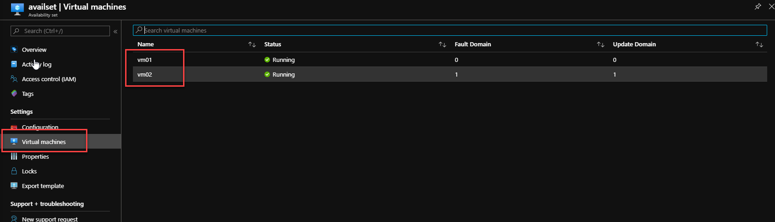’

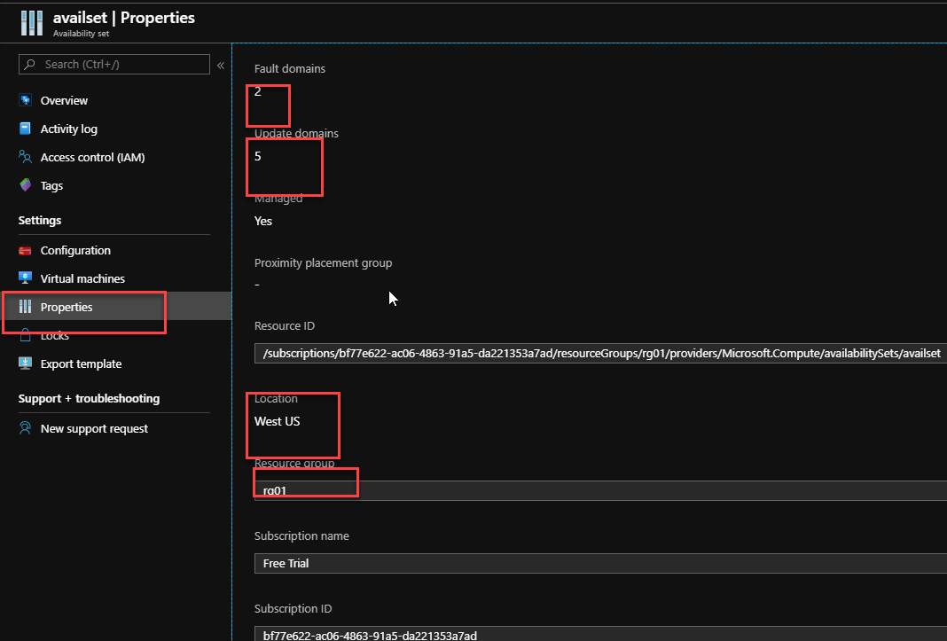

**What happens if we try to delete the availability set as it is?**

Would it delete the underlying virtual machines accordingly.

Well from the Azure portal , if we just try to delete the availability set as it is , we will get the following error message

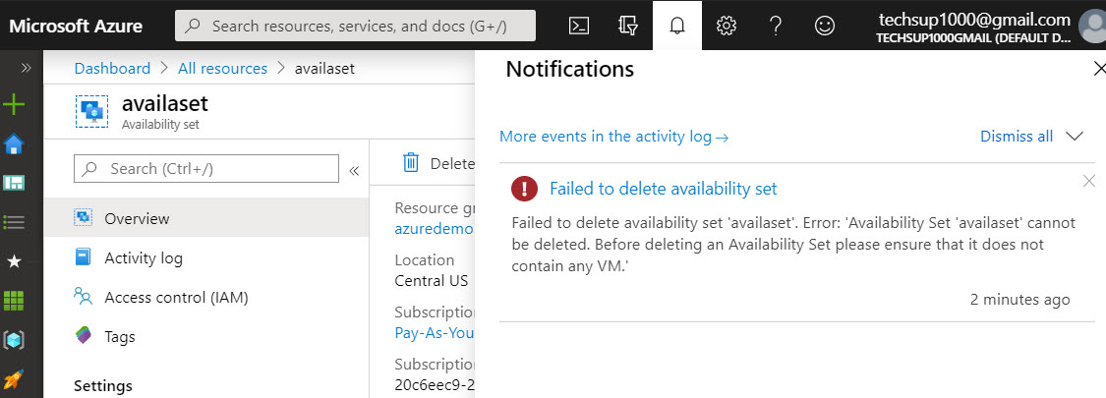

Hence we first have to ensure no virtual machine is associated with the availability set

So to delete the availability set, you can first delete the virtual machines linked to the availability set and then go ahead and delete the availability set.